30 Tons CE Approved Tube Ice Making Machine Price Easy Installation For Beverage

1, Sanitary and safe ice: Ice making water contacting parts are all adopting edible grade SUS304 and PVC material.

2, Automatic discharging outlet :(save labor and guarantee sanitary )Which can help save lot of labor cost when doing the ice business

3, High efficiency: will apply the HOT liquid Storage tank, make the machine at least make ice one more times every day.

4, Long life span: The tube we will import the Japan 304 SUS Seamless steel pipe，which can at least use for 20years.

5, Shockproof coper tube: avoiding refrigerant coper pipes and evaporator welds being damaged during transportation or using.

6, Tube ice size : 22mm, 28mm, 35mm for option , the length of the tube ice can be designed as customer need

7,High efficiency: will apply the HOT liquid Storage tank, make the machine at least make ice one more times every day.

8, Specail compressor protecting device:CBFI self-developed oil balance system makes sure lack of oil to compressor when it running.

Nice tube ice
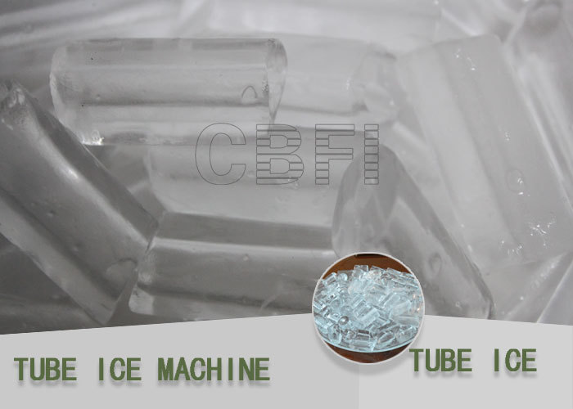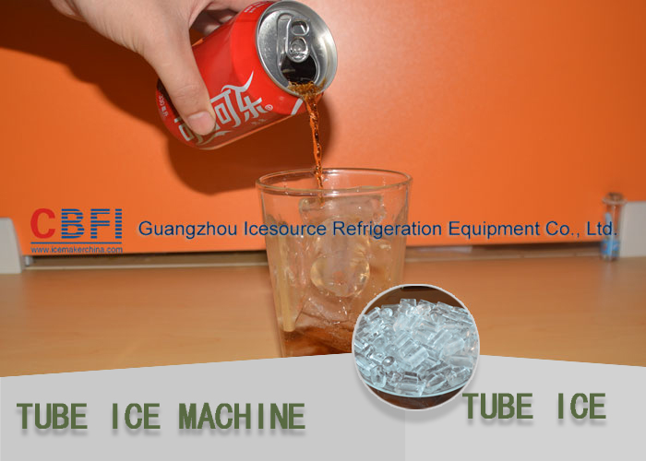

30 tons / 24hours Easy Installation Tube ice machine TV300

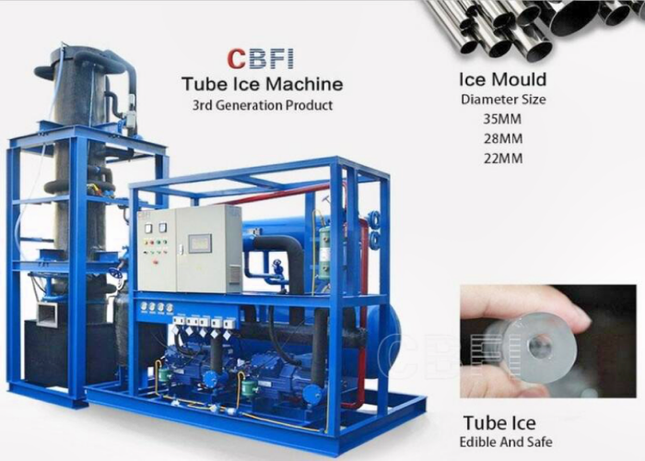

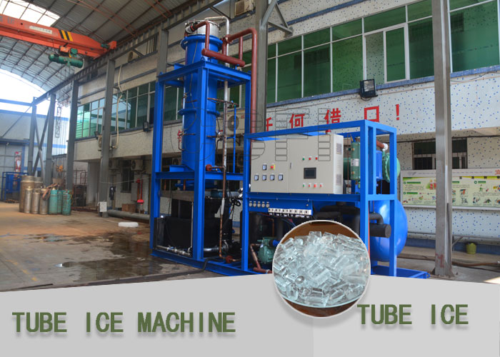

30 tons / 24hours Easy Installation Tube ice machine Tube ice machine feature

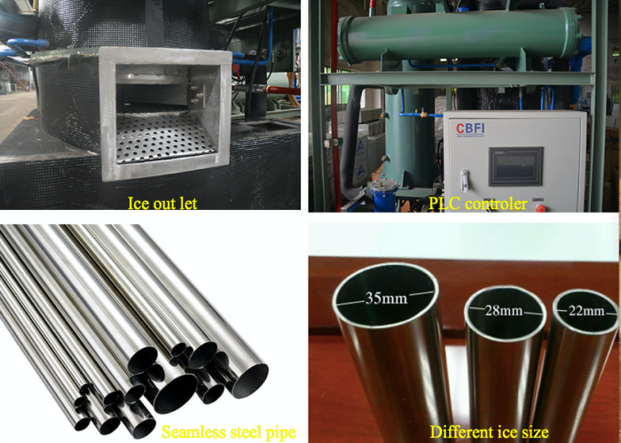
The above picture :
1,ice discharging outlet
2,PLC controller
3,Japan 304 SUS Seamless steel pipe
4,3 type of ice size for option
we can also offer different capacity tube ice machine from 1 ton to 50 ton per day (24hours)
Model | Capacity | Rated Power | Circulating Water Pump Power | Water Pump Capacity | Cooling Fan Capacity | Ice Cutter Motor | Dimension | weight
No. | Ton/24h | Kw | Kw | Kw | Kw | Kw | WxHxL(mm) | Kg
TV10 | 1.0 | 4.28 | 0.55 | 1.1 | 0.18 | 0.75 | 1100x900x1760 | 900
TV20 | 2.0 | 7.77 | 0.55 | 1.5 | 0.37 | 0.75 | 1250x1000x1950 | 1200
TV30 | 3.0 | 12.33 | 1.1 | 1.5 | 0.56 | 0.75 | 1400x1100x2200 | 1500
TV50 | 5.0 | 21 | 1.5 | 2.2 | 0.75 | 0.75 | 1600x1400x2250 | 1800
TV100 | 10.0 | 29.2 | 1.5 | 4 | 1.5 | 1.5 | 1200x1200x3100  2300x1550x1800 | 3500
TV150 | 15.0 | 49 | 2.2 | 5.5 | 1.5 | 1.5 | 1500x1200x4500  2700x1950x2250 | 4250
TV200 | 20.0 | 58.5 | 2.2 | 5.5 | 2.2 | 2.2 | 1600x1300x4700  3100x2200x2250 | 6500
TV300 | 30.0 | 87.6 | 2.2 | 15 | 2.2 | 2.2 | 3000x2200x2500  2200x1900x6200 | 7200

30 tons / 24hours Easy Installation Tube ice machine Application

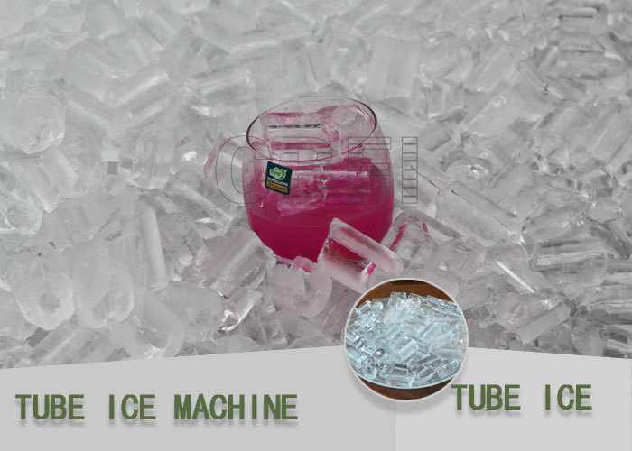

- The tube ice widely used in : drink shop ,bar, store, food processing enterprises, restaurant, hotel…

30 tons / 24hours Easy Installation Tube ice machine parameters

Working condition | Power supply | 380v/50Hz/3phase , 380v/60Hz/3phase ,  220v/50Hz/3phase, 220v/60Hz/3phase
Working condition | Refrigerant | R22 / R 404a
Working condition | Cooling way | Water cooling / Air cooling
Working condition | Max. Ambient temp. | +45 ℃
Working condition | Supply water temp | 23 ℃
Working condition | Evaporating temp. | -12 ℃
Working condition | Condenser temp. | +40 ℃
Working condition | Relative humidity | 85 %
Working condition | Noise | 55dB

Compressor | Brand Name | Bitzer (From Germany)
Compressor | Type | Semi-Hermetic Piston type
Compressor | Product Model | 6FE-50 (50HP) *3
Compressor | Power | 87.6kw
Compressor | Refrigerating Capacity | 249.9 kw
Cooling Tower | Brand Name | CBFI
Cooling Tower | Size | Φ3100*2650 mm
Cooling Tower | Power of Cooling Water Pump | 11 kw
Cooling Tower | Power of Cooling Fan | 2.2 kw
Cooling Tower | Cooling Water Consumption | 0.05 m3/h
Ice making water Circulating pump | Brand Name | Nanfang
Ice making water Circulating pump | Power | 2.2 kw
Ice Cutter Motor | Brand Name | Rador
Ice Cutter Motor | Power | 2.2 kw

30 tons / 24hours Easy Installation Tube ice machine Main components

Item No. | Name of Components | Brand Name
1 | Compressor | Germany Bitzer
2 | PLC | Germany SIMENS
3 | Expansion valve | Denmark DANFOSS
4 | Solenoid valve of Water supply | Denmark DANFOSS
5 | Oil filter | America Emerson
6 | High and low pressure meter | Switzerland REFCO
7 | Electrical components | South Korea LG (LS)
8 | Circulating water pump | China Nan Fang
9 | Evaporator Material | Stainless Steel 304 (SUS304)

Supporting equipment
- Ice bin for ice packing.
- Cold room for storing ice and keep the ice in high quality.
- Bag sealer for ice bag sealing
- Digital scale for ice weighting

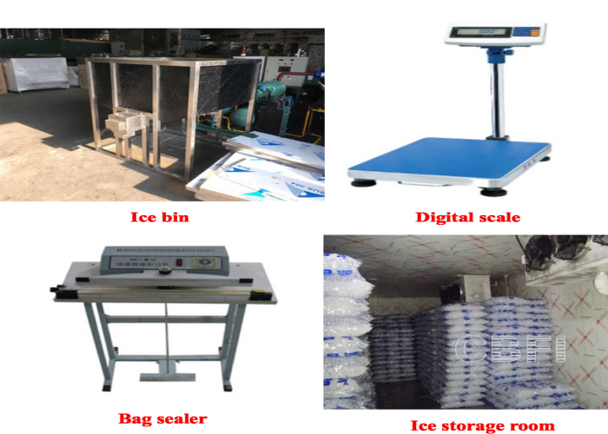
Customer case

- 7 sets 30 ton tube ice machine for South Korea
- 2 sets 30 ton tube ice machine for Malaysia
- 1 sets 30ton ,1 sets 15 ton , 1 set 10 ton tube ice machine in Indonesia

Tube ice machine testing in the factory

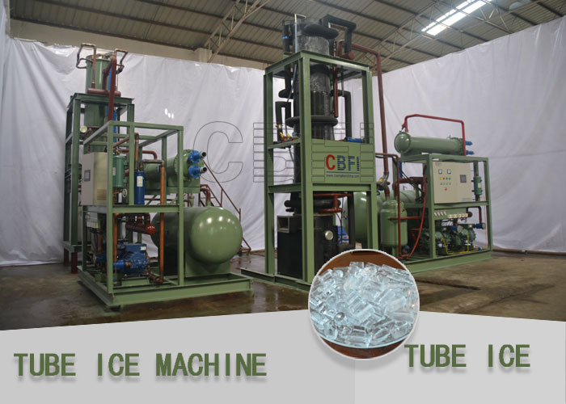

FAQ

Q1: What configuration of the voltage of the machine is ?

A: We adopt standard voltage -380V/3P/50Hz usually, non-standard voltage can be customized, the price is extra.

Q2: What’s your usual practice about terms of payment ?

A:The payment can be T/T,L/C,Western Union, Money Gram and in Cash.
The deposit is 30%, after we receive your deposit, we will start to produce the machine for you.
The balance 70% should be paid before shipping.

Q3: How long is the time of delivery?

A: The delivery time normally is 30 days after we receive the deposit.
If necessary, we will arrange the shipping for you.

